Attention 2027 Grads!

SD42 DUAL CREDIT
MEDICAL OFFICE ASSISTANT (MOA)

Are you ready to start your post-secondary career?

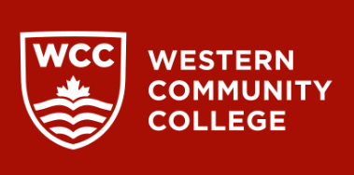
If so, explore SD42’s Dual Credit option. SD42 has formed a partnership with the Western Community College (WCC), allowing students to complete all MOA course work prior to graduation! And SD42 pays the tuition!

Western Community College is a proud partner of the Canadian College of Health Information Management (CCHIM). The CCHIM is a national, not-for-profit corporation that sets the accreditation standards for educational institutions and certification standards for health information professionals in Canada.
https://wcc.ca/programs/health-care/medical-office-assistant/

Once successfully completed, MOA Graduates can make $31 per hour and can enter into the following occupations.
- Medical Office Assistant: Manage administrative tasks in medical settings.
- Medical Receptionist: Greet and assist patients in clinics.
- Medical Records Clerk: Maintain patient health records.
- Billing Specialist: Handle medical billing and insurance claims.
- Clinical Assistant: Support healthcare providers with patient care.

Here’s how the MOA program works

The program begins September 2026 and will run on a day about schedule for the school year. The day about schedule allows MOA students to take four courses at their home school every other day, with MOA courses on the alternate days. Teaching in the program is synchronous virtual learning; meaning the course work occurs in real time - online. But, if enough students apply to form a cohort, WCC will send an instructor to SD 42 for in person instruction!

If you are interested or have any questions, please contact Penny Griffin (SD 42 Dual Credit Implementation) at penny_griffin@sd42.ca.

