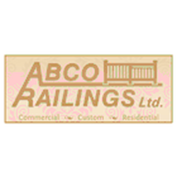
Metal Fabrication Shop is looking for a shop/field worker:

Must have valid driver's license
Welding experience would be an asset
$15 - $18 per hour
Full time employment

Contact: ABCO @ 604-460-6633
Or
Rob Heinze @ Cell: 604-671-0107

